PROJECT PLANNING

Plan:
For the management of a hospital and foundation criteria of this system we put on our intend for the project into –

- Reception & Discharge for both of the indoor and outdoor patients.
- Available treatments of the patient and keeping their every information for instant and for future.
- Adding new features to the management system of the Hospital.
- Administration for controlling the overall software.
- For the convenience of customers we decide to deliver them a package of software features containing the desirable software for each part.
Objectives:
- To create a database of available rooms for the Patients entry, Doctors and stuffs.
- To generate all the information of overall charge of the patient under the service is delivered.
- To make the database able to search the necessary information from any interface.
- Besides information database may includes any new features and which control the administrator for overall Hospital Management.

Scope:
The Scope of this project is defined as:
- This software will be the databases of accessing software-containing doctors, indoor and outdoor patients, stuffs, store room, overall billing system.
- This software will contain possible combination of all the interfaces which all share the same database and same server. With which the user can easily handle overall the system. The interfaces are:
- Reception the indoor and outdoor patient, bill, new Doctor or stuff Addition or external doctor addition and their working period Interface.
- New ward, bed, cabin, general bed and paying bed entry interface.
- Administration Interface where any new user account may create.
- Discharge the patient and report making interface.

- Every interface along the database will be connected together by Network. Here we assume LAN will be used.
- Every interface will have the privilege to search any necessary information anytime and view the result.
- Administrative Center can access any information from database.

Technical Risks:
- User may give inputs that are invalid in data type. We have to check every user input for valid data and give a prompt whenever invalid.
- In user input, some attribute field may be empty. We check and give a prompt if the field is obligatory.
- Since our development suggests data centric architecture. There is a possibility of losing data by ‘connection breakdown’ during transaction. So we have to handle it.

Resources:
- Human Resources:
Every project has a defined number of people on the software team.
We are only 3 members for developing the software and we construct every ingredient sharing our feelings. But we move like a team in every incidence for developing the software. We feel we may act like:
    - Project Manager team,
    - Software Engineer team,
    - Programmer team.

  - Duration 90 days

- Reusable Software Resources:
  - Every component is new.
  - No component is reused.

- Environmental Resources:
  - Jbuilder10–for building graphical user interfaces
  - Oracle 9i –for building database
  - Microsoft Office Visio -for drawing purposes

COST ESTIMATION

- Software cost and effort estimation never be the same because of too many variables-human, technical risks, environmental, political can affect the ultimate cost of software and effort applied to develop it. However, software project estimation can be transformed from a black art to a series of systematic steps that provides estimates with acceptable risk.

- The cost estimation fully depends on the user satisfaction. From the economic point of view satisfy the user is a tuff job.

- The principal components of project costs are:
- Hardware costs.
- Travel and training costs.
- Effort costs (the costs of paying software engineers).
- We decompose cost estimation for the product in the following manner:
  - First we had to pay attention upon the requirement collection.
  - Secondly the material cost to establish our plan was added with that cost. To ensure the quality of the software the additional cost were provided into the budget.
  - Quality cost is divided into cost associated with prevention, appraisal and failure.
  - Prevention cost includes quality planning, formal technical reviews, text equipment and training.
  - Appraisal costs include activities to gain insight into product condition the first time through each process. In our project the appraisal cost includes in-process and inter-process inspection, equipment calibration and maintenance.

- Our project also includes failure costs. It is sub divided into:
  - Internal failure cost: includes rework, repair and failure mode analysis
  - External failure cost: includes compliant resolution, product return and replacement, help line support and warranty work.

PROJECT SCHEDULE

Project Schedule:
Software project scheduling is an activity that distributes estimated effort across the planned project duration by allocating the effort specific software engineering tasks. The project manager’s objective is to define all project tasks, build a network that depicts their interdependencies, and identify the tasks that are critical within the network, and then track their progress to ensure that delay is recognized “one day at a time.” To accomplish this manager must have a schedule that has been defined at a degree of resolution that allows progress to be monitored and the project to be controlled.

- Compartmentalization: This project can be compartmentalized into following parts:
  - Reception Interface
    - Add Request
    - Search Request
  - Searching Interface
    - Search Request
    - Add request
  - New Doctor or stuff Addition Interface
    - Add Request
    - Update Request
  - New Ward ,Cabin or bed entry
- Add Request
- Update Request
  - Log on Interface
    - Search Request
  - Report Generation Interface
    - Search Request
    - Add Request
  - Administrative Interface
    - Search Request
    - Add new Request to the database
    - Create new user account

- Interdependency: can be stated as below
  - Every interface is parallel in any request. They can search database independently.
  - Reception, Discharge, New Doctor or stuff Addition Interfaces, New ward, cabin entry and Report Generation Interface can add new record independently.
  - The doctors in charge of the patient, billing system on the category can do independently without affecting any tasks.
- Time allocation: We had allocated at most 90 days. So we planned for developing our product within the allocated days.
  - 3 programmers develop 3 major interfaces simultaneously. So, interdependency has no effect on this project.
  - Work is done in a full-time basis.

- Effort validation: is defined as below
  - On each day, 3 concurrent tasks must be accomplished. Each task requires 1 person day of effort.

- Defined responsibility: can be stated as below
  - Each programmer works at his or her assigned tasks (interfaces).
  - Project manager team guides and schedules them as a regular basis.

- Defined outcome: can be stated as below
  - Every task should produce a corresponding interface of its own.
  - All interfaces will then be joined to get the deliverable.

- Defined milestone: of each task is stated below
  - Reception Indoor or Outdoor Patient, Delivery and New Dr. Addition Interface
    - Should have access to database for searching process of patients and Doctors
    - Should have full access to database for updating process
    - Should have access to database for adding process
    - Should be completed within 70 days
    - User interface should be friendly
    - Help system should be available and rich
  - Report Generation Interface
    - Should have access to database for searching information
    - Should have partial access to database for updating process
    - Should have access to database for adding process
    - Should be completed within 70 days
    - User interface should be friendly
    - Help system should be available and rich
  - Administration Interface
    - Should have access to database for searching information
    - Should be completed within 70 days
    - User interface should be friendly
    - Help system should be available and rich

Work Schedule:
Each task to be scheduled must be allocated some number of work units. Each task must be assigned a start date and completion dates that are a function of the interdependencies. We allocated our time according to the following schedule table that was formed at the start of our journey.

Description of the task | Starting date | Completion date | Comments
Communication | April 24, 2006. | April 27, 2006. | Completed
Planning | May 01, 2006 | May 13, 2006 | Completed
Modeling | May 14, 2006 | May 25, 2006 | Completed
Construction | Dec 01, 2006 | Dec 26,2006 | Completed
Deployment | Dec 28, 2006 | Onwards…… | …………………………

Emphasis was given on the planning and construction phases as they were the complex part of the schedule. After the time has been allocated it was the ask of the time to distribute our effort upon the allocation to demonstrate the up gradation of the task scheduled.

REQUIREMENT ANALYSIS

OBJECTIVE:
It is obligatory to understand requirements before design and construction of software. To accomplish this, a set of requirements engineering tasks are conducted which begins at communication activity & continues up to the modeling activity. Here we focus on how we communicate with the customers & planning activity for our hospital management s/w project which is followed by requirement engineering process. Requirement engineering process builds a bridge to design and construction. It provides the appropriate mechanism for under standing what the customer wants, analyzing need, and assessing feasibility, negotiating a reasonable solution, specifying the solution unambiguously, validating the specification and managing requirements as they are transformed into an operational system. Above all, the basic objective of requirement engineering is to define customer’s desire & establish a solid foundation for the design & construction of s/w which will fully satisfy the customer’s desire. The requirements engineering process is accomplished through the execution of seven distinct functions. They are as follow:
- Inception
- Elicitation
- Elaboration
- Negotiation
- Specification
- Validation
- Requirement Management

INCEPTION:
It is the initial phase for requirements engineering. A software project begins with the identification of business needs and the nature of problems to solve by primary communication between customer and developer.
- Identifying Stake-holder:
  - Administrative officials
  - Patients
  - The people who are related with the service sector of the hospital

- Recognizing multiple view point:
- Administrative officials:
- The goal of Administrative officials is to get total control over the managing the hospital .It will help them by people allocation & distribution of their resources. Define users and their access privileges. Patient registration, visit slip, search facility, appointment, billing scheduling must be maintained. Ensure the best services to the patients and increasing their goodwill.

- Patients:
  - Out patients: They need appointment scheduling, visit slip generation, doctor’s daily appointment list, medical observation, drug prescription.

  - In patients: They need wards, rooms and beds configuration, patient’s admission request, bed occupation information, admission and bed allocation, electronic patient record, drug prescription, discharge summary and details information.

  - Other related people:

- Service module:
- Configuration of services offered
- Integration with patient’s billing module
- Check availability of ambulance
- Immediate availability of investigation reports in electronic medical records

- Financial module:
  - Patient billing:
    - Patient billing and collection
    - Financial posting to financial accounting module

  - Payroll:
- Employee’s personal details
- Leave and advance management
- Loans and advance management
- Employee’s promotion, transfer and resignation
- Payroll processing
- Payments to the suppliers.

- Working toward collaboration:
We carry out the decisions together. We discuss about each and every component of the software in detail. We carry out this part by following the requirement engineering process strictly.

- Asking the first question
- What types of user will be in hospital management?
- What will be the access privileges to those accounts?
- What types of patient come to hospital?
- What types of services hospital offer to the patients?
- What will be the billing rate?
- What are the requirements that you have to fulfill the security of the system?

ELICITATION:

Collaborating requirements gathering:
- Meetings are conducted and attended by both software engineers and customers (along with other interested stack-holders).

- Rules for preparation and participation are established.

- An agenda is suggested that is formal enough to cover all important points but informal enough to encourage the free flow of ideas.

- One of us controls the meeting.

- The goal is to identify the problem, propose elements of the solution, negotiate different approaches, and specify a preliminary set of solution requirements in an atmosphere that is conductive to the accomplishment of the goal

Quality function deployment:
- Normal requirements:
  - To satisfy all types of hospital management works.
  - Easy access and reliable high security system.

- Expected requirements:
- The coding system has to be efficient enough to support the commonly used computer system (operating system).
- Different access level.

- Exciting requirements:
- As the time is very sort time, so there is no exciting element.

ELABORATION:
- Information obtained from customer during inception and elicitation is expanded and refined during elaboration.
- It is a planning activity that defines functional and behavioral domain of problem.

NEGOCIATION:
- We negotiate with the customer for analyzing risk and estimation of cost.
- Requirements are added, removed, combined or modified in that approach with both parties satisfaction.

SPECIFICATION:
- Patient admission & discharge is done automatically.
- On-line billing system is available.
- Patient’s report, doctors schedule, drug prescription these are available in electronic way (internet) and it is upgraded time to time.

VALIDATION:
- This phase examines for assuring qualitative product and eliminates error, data omission, data inconsistency occurred in our s/w.
- It clarifies the missing area, conflicting and unrealistic requirements.

REQUIREMENT MANAGEMENT:

- It helps to identify, control &track requirements.
- It helps to search how data is related one-another and what type of change should need for requirement changing.

ANALYSIS MODELING

The requirements those have already been procured from the customer are validated by the analysis modeling. It exploits combination of text and diagrammatic forms to depict requirements for data, function and behavior in a way that is relatively easy to understand and strait forward to review for correctness and consistency. Analysis model is the bridge between the system description and design model.

Analysis model must have three primary objectives:

- To describe what the customer requires:
As we are demonstrated to develop large scale software “Hospital Management System”, we tried our best to procure well-fitted requirements for the desired system. But we were not stipulated with any actual customer. So, we resolved to set up an imaginary infrastructure of the system with our intellectual sense.
- To establishes a basis for the creation of software design.
We went to the local railway station to be perceived with the professional software. Firstly, we were fallen into an adverse situation; but lastly we were succeeded to be introduced with that. This initiative helped us to establish a basis for the creation of the software.
- To define a set of requirements that can be validated once the software is built.
Firstly, we defined the system core of the overall problem domain. Then gradually the system core was expanded on accordance with our vexed functionality. Elements of the analysis model: Analysis model has four basic elements. Those elements are:

- Scenario-based elements: These are composed of use-case- text, use-case- diagram, activity diagram and swim lane diagram.
- Class-based elements: These are composed of class diagram, analysis packages, CRC models and collaboration diagram.
- Flow-oriented elements: These are composed of data flow diagram, control flow diagram and processing narratives.
- Behavioral elements: State diagram and sequence diagram.

- Here we providing USE-CASE and ACTIVITY diagram for user, doctor/stuff and administrator:

USE-CASE diagram for User

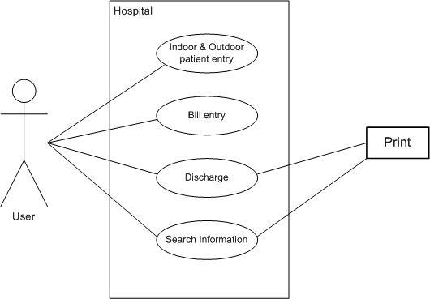

USE-CASE diagram for Doctor/Stuff

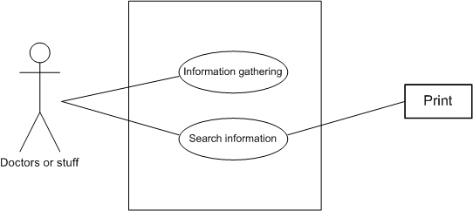

USE-CASE diagram for Administrator

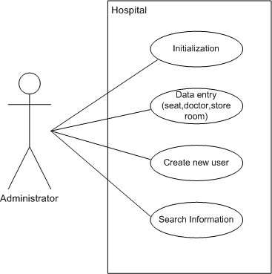

ACTIVITY diagram for User
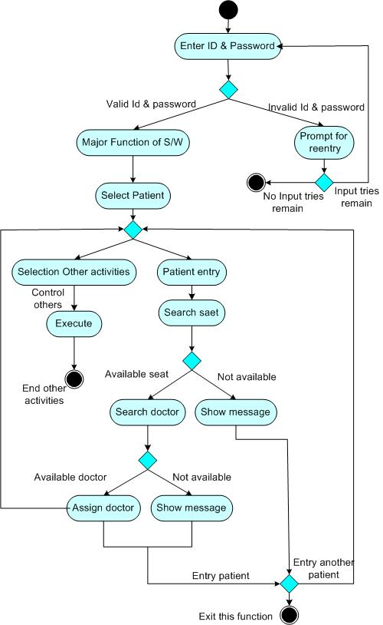
Fig: Activity Diagram for User
ACTIVITY diagram for Doctor/Stuff

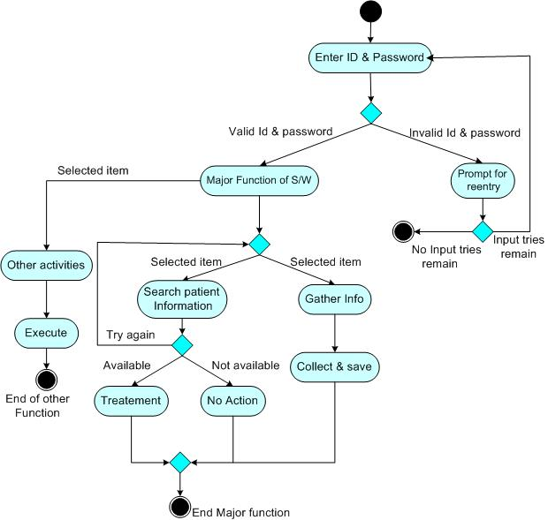

Fig: Activity Diagram for Doctor/Stuff

ACTIVITY diagram for Administrator

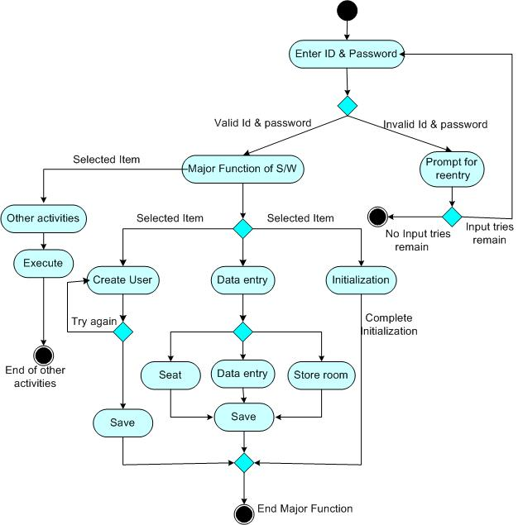
Fig: Activity Diagram for Administrator

CLASS BASED MODELING

As we developed large scale software “Hospital Management Software” so it has many classes. Here we are providing a class diagram that will focus our major classes.
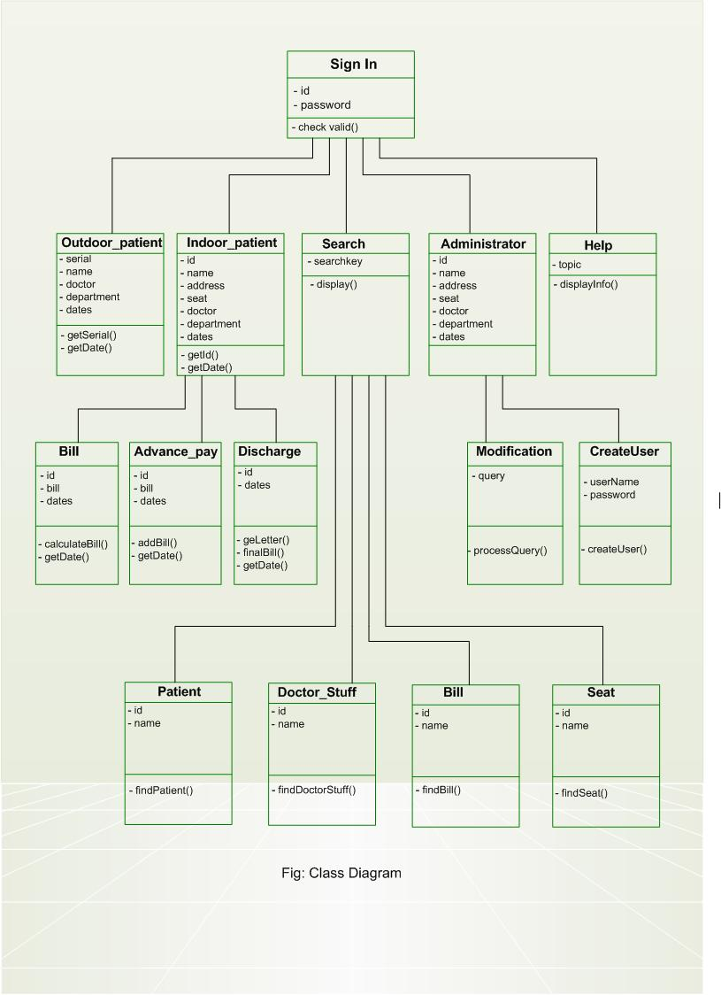
DATA FLOW MODELING

The DFD is a sample graphical notation that can be used to represent a system in terms of the input data to the system, various processing carried out on these data to the output data generated by the system. The main reason why the DFD technique is so popular is on account of the fact that it is a very simple formalism, it is simple to understand and use.

- The Inputs of our Software:
- Indoor Patient Entry
- Outdoor Patient Entry
- Seat Entry
- Bill Entry
- Doctor/ Staff Entry
- Accessories Entry
- Log in as User/Administrator/Officials
- New User

- The Outputs of our Software:
- Display
- Printer

The graphical representation (DFD) of our system is mentioned below:

Level 0 DFD

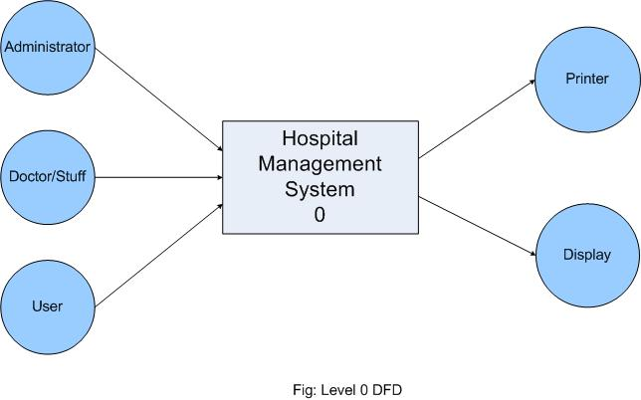

Level 1 DFD

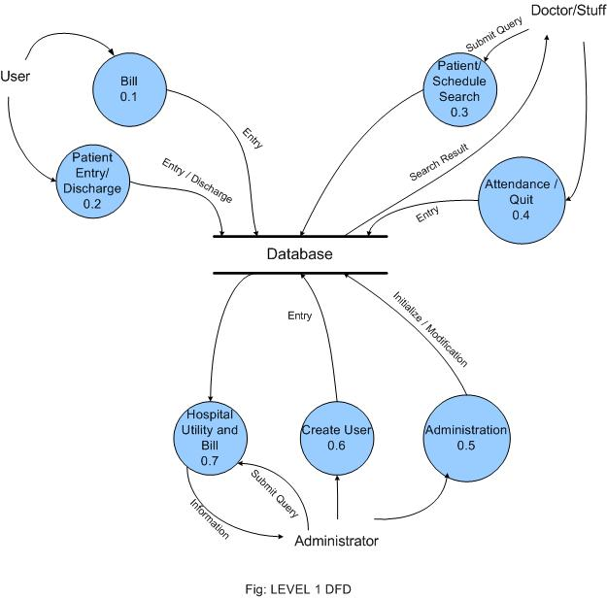

Level 2 DFD

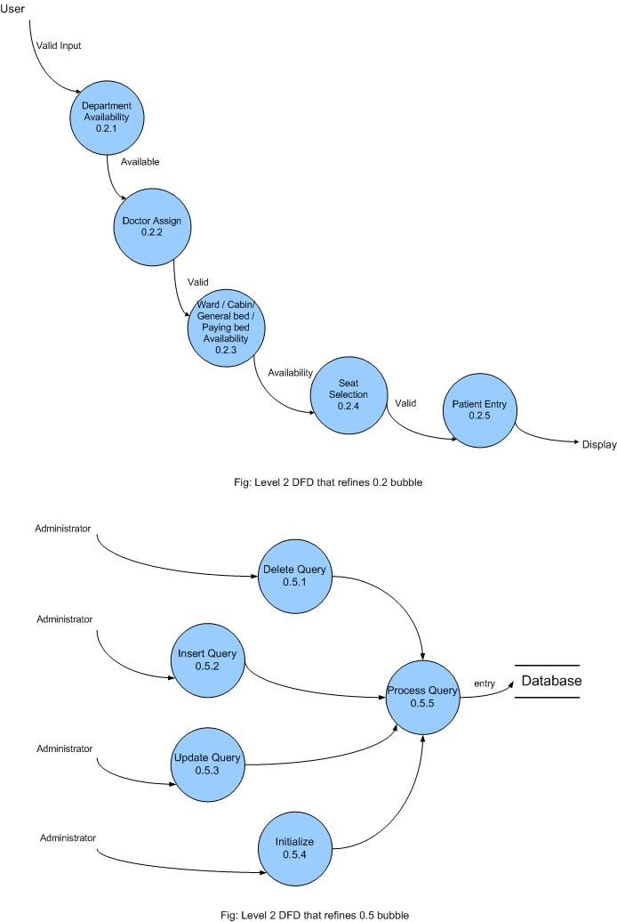
DESIGN MODEL

Design modeling is the place where customer requirements, business needs and technical consideration all comes together in the formulation of a product or system. Design creates a representation or model of the software but unlike the analysis model. The design model provides detail about software data structure, architecture, interfaces, and components and components that are necessary to implements system.

Design allows the software engineer to model the system or product that is to be built. Design is the platform where software quality is established. We developed our software interface on the basis of E-R diagram of the data base and on the overall system architecture. E-R diagram and overall system architecture is exploited from the analysis modeling. All the components of analysis model have a parallel connection with the component of the design model.

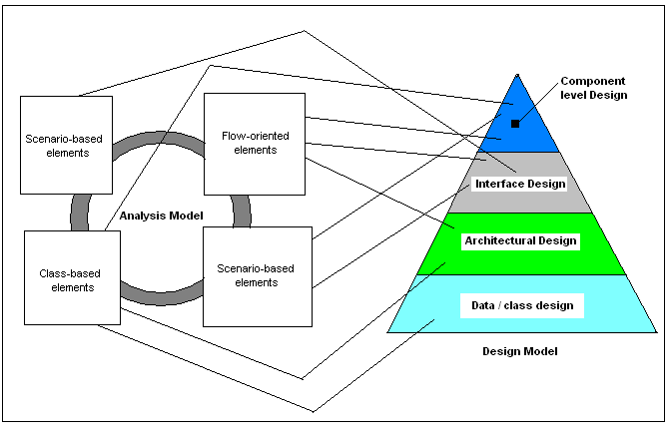
FIG: Translating the analysis model into design model

ARCHITECTURAL DESIGN

Architectural design represents the structure of data program components that are required to build a computer based system. It considers the architectural style that the system will take, the structure and properties of the components that constitute the system and the interrelationships that occur among all architectural components of a system. In a word, architectural design focuses on the representation of the structure of software components, their properties and interactions.

Although a software engineer can design both data and architecture, the job is often allocated to specialists when large complex system is to be built. Architectural design begins with data design and then proceeds to the deviation of one or more representations of the architectural structure of the system. Alternative architectural styles or patterns are analyzed to derive the structure that is best suited to customer requirements and quality attributes. Once an alternative has been selected, the architecture is elaborated using an architectural design method.

In the context of our project we just followed an architectural method basing upon the following criteria:

- We designed our product’s architecture in such a way that the representation of software architecture caries on communication between all parties (the stake holders).
- Our architecture highlights early design decisions that will have a profound impact on all software engineering work that follows and, as important, on the ultimate success of the system as an operational entity.
- In addition with that we designed it such a way that it constitutes a relatively small, intellectually graspable model of how the system is structured and how its components work together.

In our “Hospital Management Software” we needed a data store at the center of this architecture and that is accessed frequently by other components that update, add, delete or otherwise modify data within the data store. Because of the high dependency of our project with this architecture finally we had decided that Data Centered Architecture is the best architectural design for our project.

Now we proving the Architectural Context Diagram (ACD) of our software

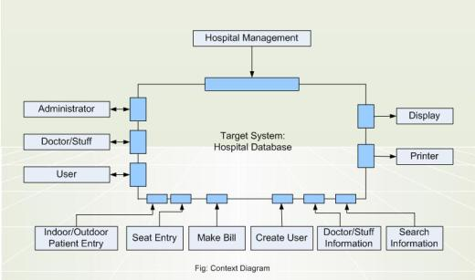

We also include here the overall architecture of the components as the diagram below:

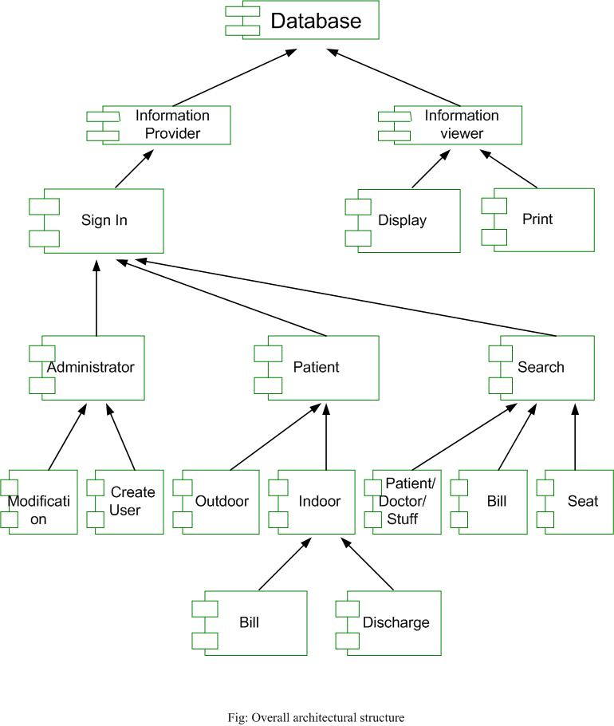

TEST PLANS

Testing plan of Software depicts on a software testing strategy for conventional s/w architectures. A strategy for s/w testing can be viewed in the context of the spiral. On the contrast of this s/w, a short definition of the spiral is discussed bellow:

- Unit testing:
  - We performed unit test for each component of our product. Major unit tests are:
    - Administrator & user login:
Here, we test our system for various id & password and see the flow of transaction for valid data.
    - Data entry:
Here, we test the system for correct entry of valid data and see transaction flow for valid data.
    - Search Operation:
See whether the information’s of a particular patient or doctor or stuff is showed correctly.
    - Bill Entry:
We tested the billing sector very carefully and satisfactorily saw that everything is quiet ok.

- Integration testing:
- We performed three integration testing:
- Bottom up integration testing
- Regression testing
- Smoke testing.

- Validation testing:

  - Alpha testing: For alpha testing, we have shown our product to our course teacher, and some of our senior brothers.
  - Beta testing: For beta testing, the software will be given to Lab De Nova and feedback will be taken in regular basis.

- System testing:
- For system testing we have done
- Recovery Testing
- Security Testing
- Stress Testing
- Performance Testing

TEST CASES FOR DESIGN CLASS

There are two types of testing. They are:

- White Box Testing:

White box tests focus on the program control structure. Test cases are derived to ensure that all statements in the program have been executed at least once during testing and all logical conditions have been exercised. White box technique which may also be defined as basic path testing makes use of program graphs to derive a set of linearly independent tests that will ensure coverage. Conditions and data flow testing further exercise program logic, and loop testing.

- Black Box Testing:

Black box tests are designed to validate functional requirements without the internal working of a program. This testing focuses on the information domain of the software, deriving test cases by partitioning the input and output domain of a program in a manner that provides thorough test coverage. Equivalence Partitioning divides the input domain into classes of data that are likely to exercise specific software function

Among the White Box Testing and Black Box testing we choose White Box Testing for our software. We choose basis path testing as a white-box testing.

Our approach to Test Cases:

- Test Case 1:

- Use Case: Welcome Screen
- Primary Actor: Administrator
- Goal:
  - Software Initialization
  - Create new User
- Trigger: No trigger
- Exception: Password invalid
- Priority: Essential
- When available: First Increment.
- Test Criteria:
  - User Name: administrator
  - Password: cse

- Test Case 2:

- Use Case: Welcome Screen
- Primary Actor: User
- Goal:
  - Search Information
- Trigger: No trigger
- Exception: No Exception
- Priority: Essential
- When available: First Increment.
- Test Criteria:
  - User Name: administrator
  - Password: cse

Deriving Test Cases:

For each class there were different test cases. Here we discuss the test cases for some our product’s major class below:

Deriving Test Cases for User:

- Flow Chart and Flow Graph for User:
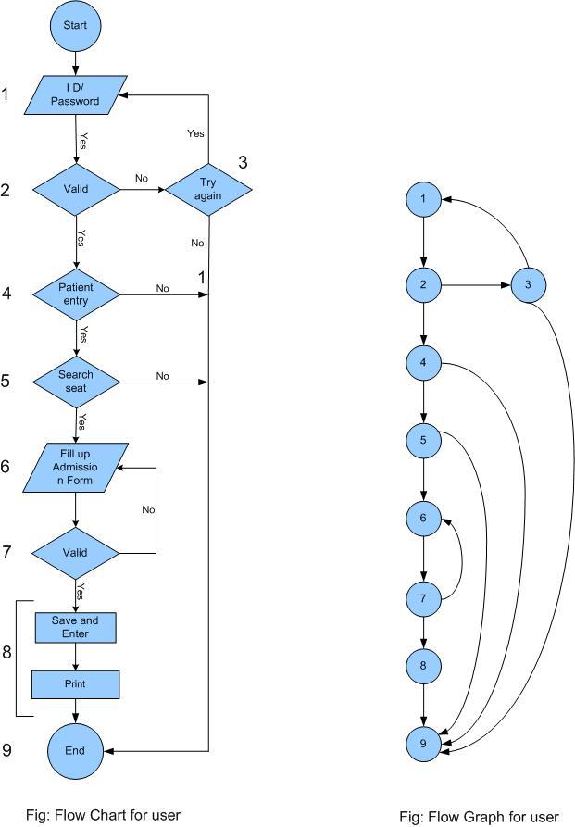
- Cyclomatic Complexity:
Here
Number of Nodes (N) = 9
Number of Edges (E) = 13
Number of Regions (R) = 6
Number of Predicate Node (P) = 5

The Cyclomatic Complexity V (G) can be defined as any one of the following ways:
V (G) = 6 regions.
V (G) = E – N + 2 = 13 – 9 + 2 = 6
V (G) = P + 1 = 5 + 1 = 6

- Independent Path:
The independent paths are:
- 1 – 2 – 4 – 5 – 6 – 7 – 8 – 9
- 1 – 2 – 3 – 9
- 1 – 2 – 4 – 9
- 1 – 2 – 4 – 5 – 9
- 1 – 2 – 4 – 5 – 6 – 7 – 6 . . . . . .
- 1 – 2 – 3 – 1 . . . . . .

Deriving Test Cases for Administrator:

- Flow Chart for Administrator:

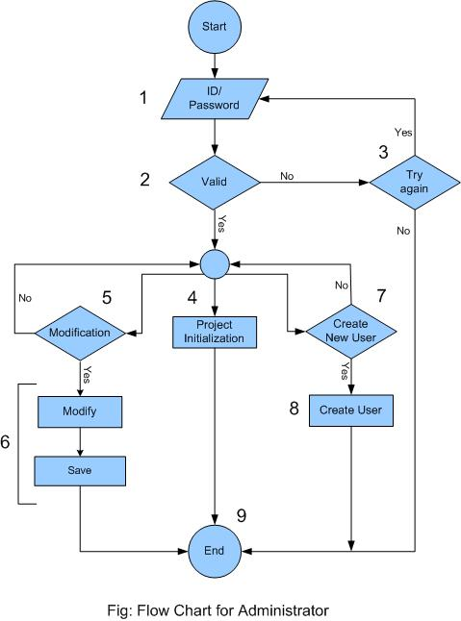

- Flow Graph for Administrator:

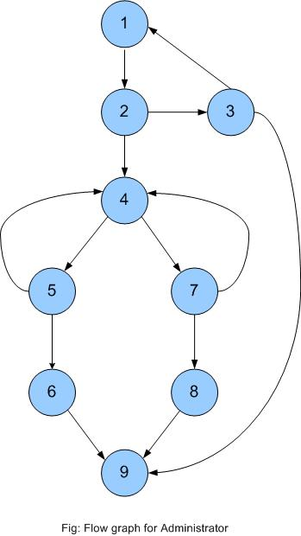

- Cyclomatic Complexity:
Here
Number of Nodes (N) = 9
Number of Edges (E) = 12
Number of Regions (R) = 5
Number of Predicate Node (P) = 4

The Cyclomatic Complexity V (G) can be defined as any one of the following ways:
V (G) = 5 regions.
V (G) = E – N + 2 = 12 – 9 + 2 = 5
V (G) = P + 1 = 4 + 1 = 5

- Independent Path:
The independent paths are:
- 1 – 2 – 4 – 5 – 6 – 9
- 1 – 2 – 4 – 7 – 8 – 9
- 1 – 2 – 3 – 9
- 1 – 2 – 4 – 5 – 4 . . . . . . . .
- 1 – 2 – 4 – 7 – 4 . . . . . .
- 1 – 2 – 3 – 1 . . . . . .

BIBLIOGRAPHY

- SOFTWARE ENGINEERING – Rogers S. Pressman
- JAVA HOW TO PROGRAM – Deitel (Fifth Edition).
- ORACLE9i The Complete Reference.

